Recipe Website

# Overall Concept

This project will be a full stack website that allows the public to sign up, log in, and then post and search for and cooking recipes. It will have the following features:

* Two types of users:
  + Administrator:
    - The site will have one administrator that logs in with the username “admin” with a password set by environmental configuration (not hardcoded).
    - The administrator shall have the ability to approve recipes to be posted to the website.
  + Regular User:
    - Regular users register for the site by entering in their details and passwords. They log into the site via email and password stored in the database. Passwords are salted in the database.
    - They can browse the site, or search the site for recipes.
    - When logged in the users can post new recipes
    - When logged in, they rate recipes on recipes.
    - They can follow other users, and get notified when the other user post new recipes.
* The main purpose of the site is to find (by browsing or searching) and rate recipes:
  + All of the details for the recipes are stored in the database
  + Records of ratings of the recipes are stored in the database.
  + The database is searchable
    - The users can do a simple text search that searches all fields in the database
    - The users can also click the search link to go to an advanced search page where they can search by individual fields (content type: cuisine, name, poster, categories: Bread Recipes, Cake Recipes, Chicken Recipes, Pasta and Noodles, Vegan Recipes [a recipe may belong to multiple categories], ingredients, steps and description)
  + **Users can post recipe by clicking the post button to post a recipe.**
  + Users can rate recipe items on a star rating of 1 to 5.
  + The user can also follow the poster of other recipes and are notified via email the followed user posts new recipe
    - **The site must implement the email functionality, send an email to the user with details on the recipe**

Pages

The site must have the following minimum set of pages / behaviour:

* **Main page:** This page lets even non-logged in users browse the recipes, it allows users to login or signup, and also lets users do simple text searching of the database.
* **Main page (Administrator mode):** When logged in as the administrator the main page shows one links to administrator only pages: the approve recipe item page.
* **Login page:** User can log into the system, after logging in successfully they are redirected to the main page.
* **Register / signup page:** User can sign up as a new user entering all their details, after signup they are redirected to the main page.
* **Administrator approve recipe page:** Through this page administrators can approve recipes to the site. Once approved the item should show up when browsing or searching the site.
* **Item details page:** This page has all the details of a recipe and provides a way for users other than the writer to rate a recipe from 1 to 5 starts. **Also only for administrator the page allows deletion of recipe.**
* **Search results page:** Whether a user does an advanced search, or a simple text search this page lists all recipes that matched their search
* **Advanced search page:** This page allows users to search by specific fields in the database (content type: recipe type, cuisine, name, poster, categories: Bread Recipes, Cake Recipes, Chicken Recipes, Pasta and Noodles, Vegan Recipes [a recipe may belong to multiple categories], ingredients, steps and description)

:

# Main Page:

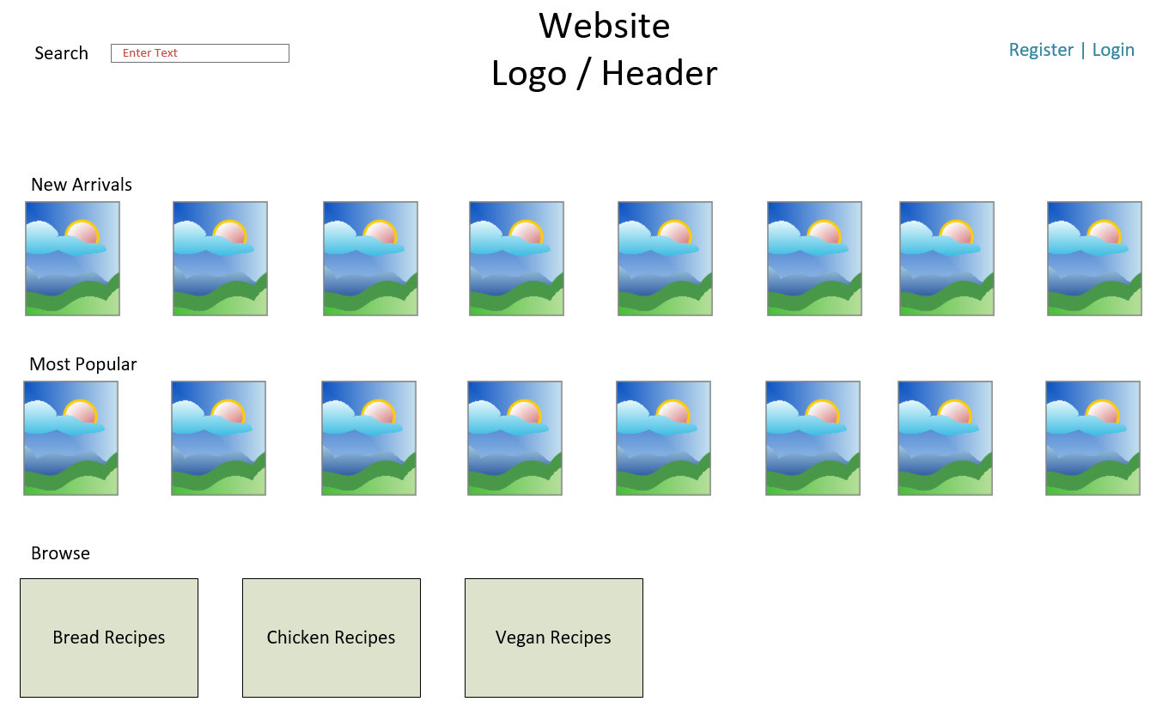

The main page has the following functionality:

* The ability to login or register for the site (link to other pages)
* A logo with the site’s name
* A simple text search box, the search text would be clickable to go to an advanced search page with the ability to search each individual field in the database.
  + Searching takes you to a search results page which lists any items that match your search
* The New Arrivals section lists the newest X (where X is configurable) items added to the store, showing the photo for the item and some way of knowing if what kind of furniture it is.
* The Most Popular section lists the X (where X is configurable) items that are the most popular at the store (as determined rating).
* The Browse section has logos to take them to the browse page for Bread Recipes, Chicken Recipes, Vegan Recipes.

# Main Page (Administrator Mode):

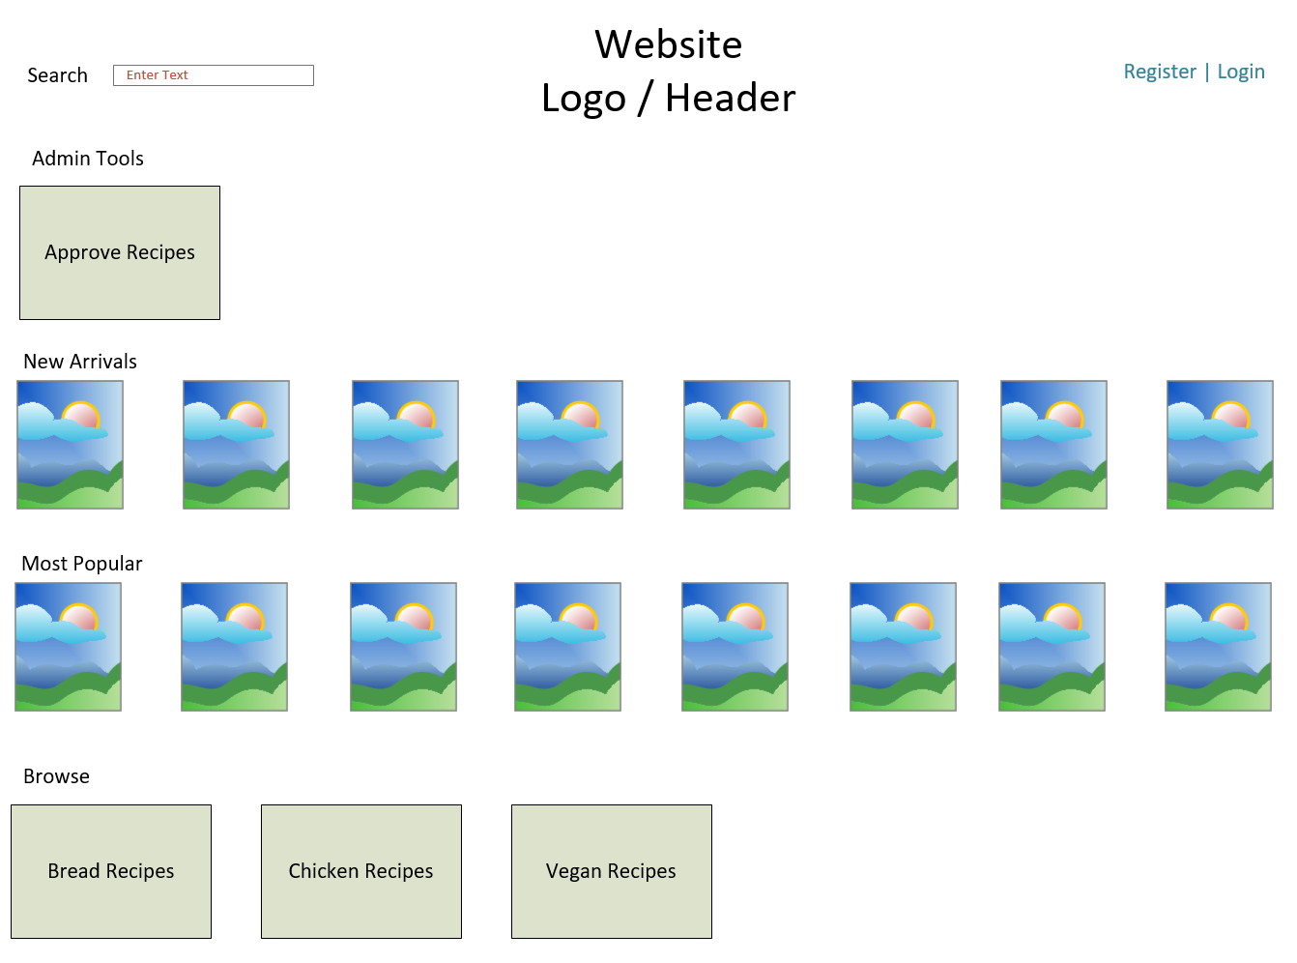

When in administrator mode the main page allows the administrator to:

* Do everything you can do in the normal main page
* A new section appears labeled “Admin Tools” with links to the Approve Recipes page.

# Register / Signup Page:

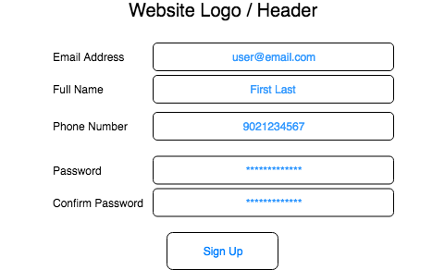

The registration page allows users to:

* Create new users in the system
* All of the fields in the page are required
* You must perform validation on the fields:
  + Emails cannot be empty strings, and must be unique in the database
  + Name cannot be empty strings
  + Phone numbers must be only digits
  + Passwords must meet some criteria (this is an excellent candidate for configurable business logic)
  + Passwords must match
* When users enter invalid data, they must be informed what’s wrong and how to fix it.
* When they successfully sign up, they should be redirected to the main page authenticated against their new user.

# Login Page:

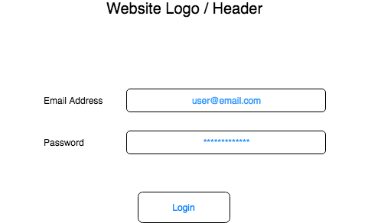

The login page must:

* Allow the user to login as a registered user via email and password OR as an administrator by entering “administrator” in the email address and the administrator password in the password box.
* The users email address and password are validated, if they match, they are logged into the system and redirected to the main page.
* Bonus points: Add the ability for users to retrieve or reset their passwords by clicking a “Forgot Password” link where they enter their email address and the system emails them a link to reset their password.

# Add/Edit Item Page

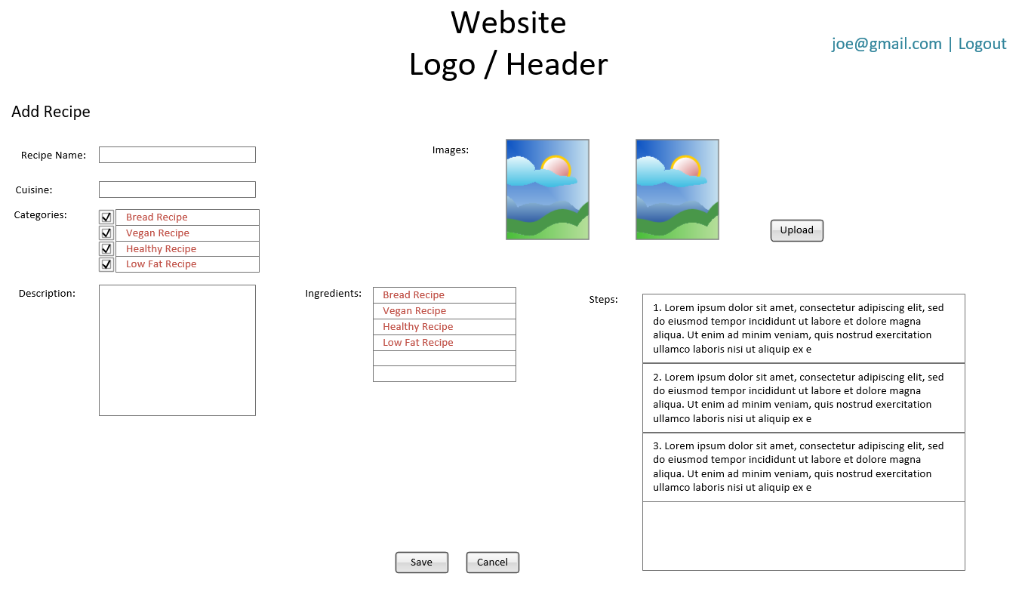

The add item page must:

* Have the following information:
  + cuisine, name, poster, categories: Bread Recipes, Cake Recipes, Chicken Recipes, Pasta and Noodles, Vegan Recipes [a recipe may belong to multiple categories], ingredients, steps and description). There could be categories which are mutually exclusive (e.g. Vegan, Vegetarian, and Chicken etc.)
* When the user clicks save all data is saved in the database for a new entry in the library. The photo can be uploaded to a file structure on the server or stored in the database.
* Cancel returns the user to the main page.
* The page must not allow the user to enter duplicate items in the database (items are considered duplicates; a recipe is a duplicate if it has the same name.

# Approve Recipe Page

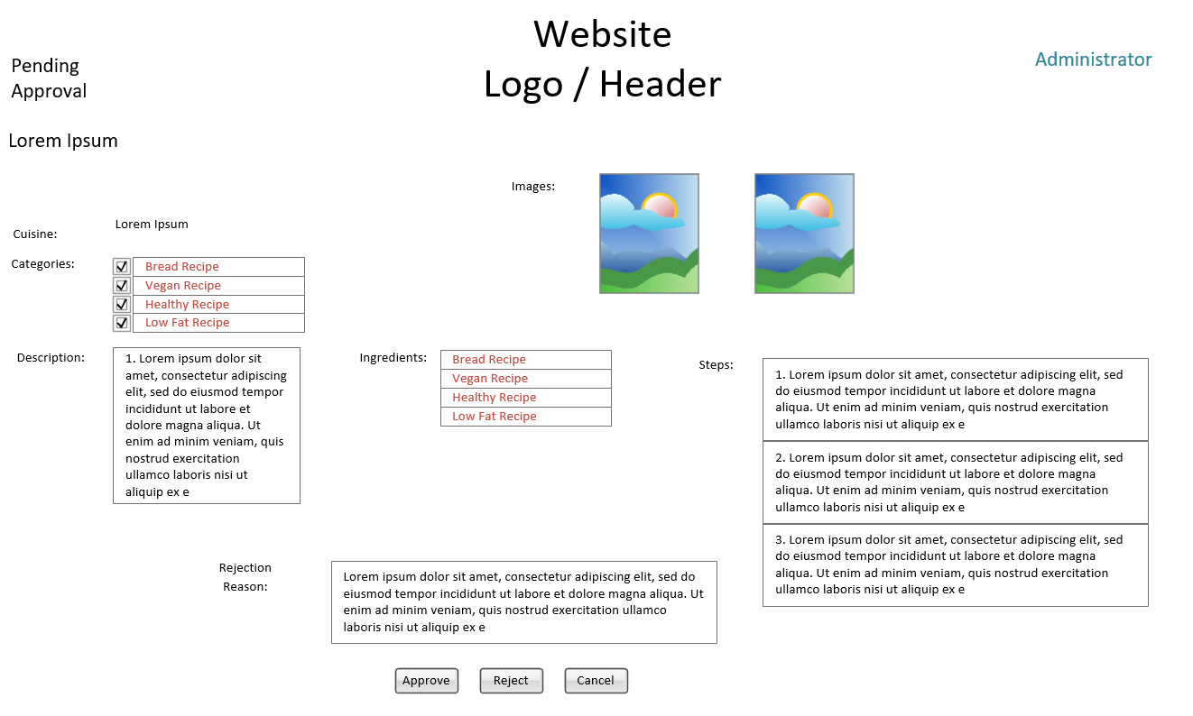

The Approve Recipe Page must:

* Display first Pending Approval Recipe
* When the user clicks Approve or Reject, the status is updated. If the action is reject then the rejection reason is required and is recorded in the database. This then triggers a process that emails the poster about the decision. The item is now available in general viewing.
* Then the next item is displayed.

# Item Details Page

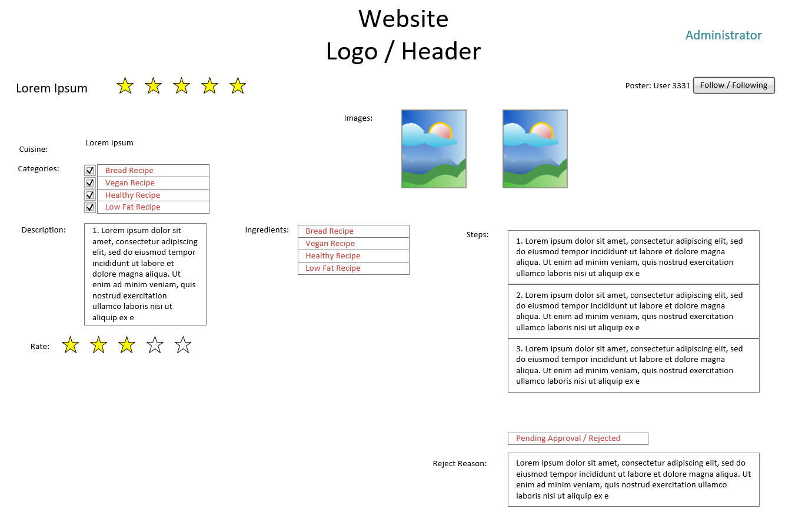

The Item Details Page must:

* Adapt to the context of the item to display the all available information. If the user is the poster, then follow/following is not shown and if the item is pending approval or Rejected then the status is show, If it is rejected then reject reason is shown. If the item is approved then average star rating is shown. If the user is non poster than rate action is shown (which is updated as soon as a star is clicked). Also for non poster a follow or following toggle button is displayed.
* Display the item’s images.
* If the Poster is logged in then a button to “Edit” is shown clicking which should redirect to Edit Item Details Page (which is similar to Add Item Details Page)

# Search Results Page

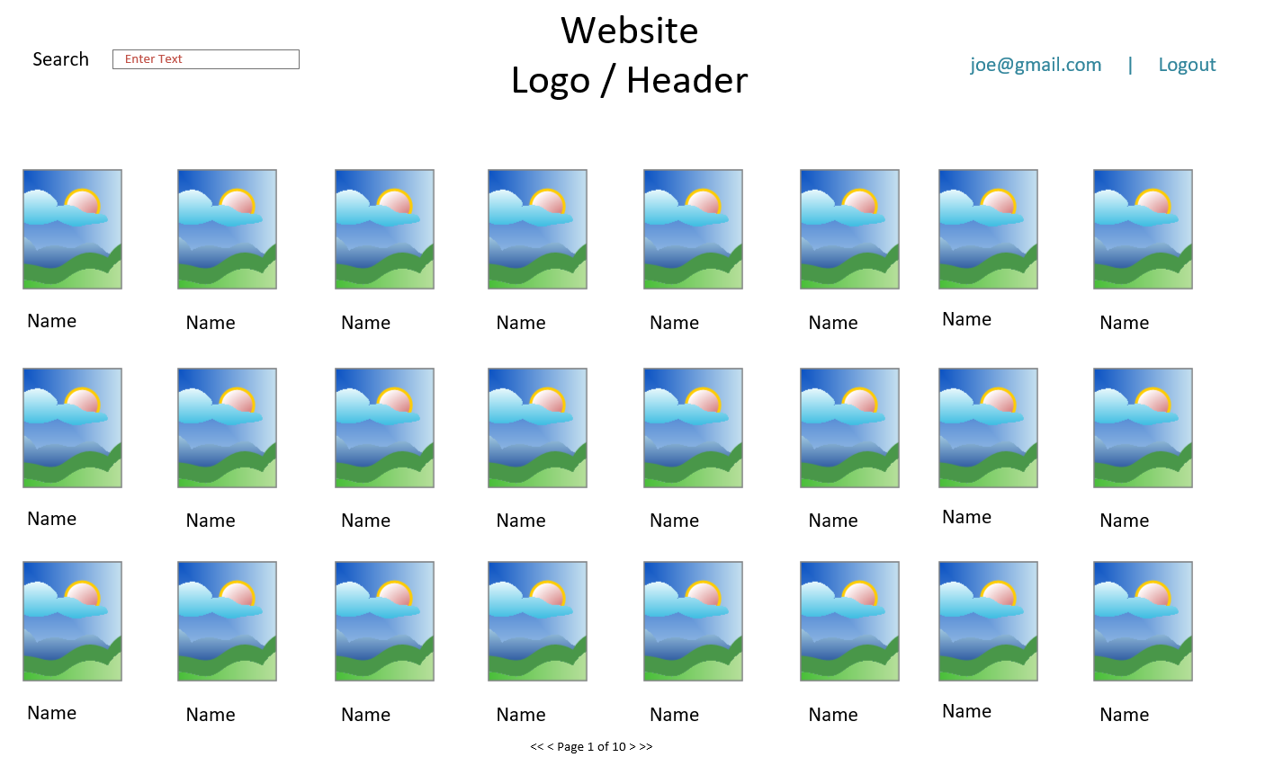

The search Results Page must:

* Display the results of the search, the item’s image, and the item’s title
* The results should be displayed in the context of the search. For example, if the user did an advanced search where they searched only vegetarian recipes only vegetarian recipes should be displayed.
* Pagination should be used to show if search returns more items than can be displayed on one page.
* Clicking any search result’s photo takes you to that item’s item details page.
* The search box should be prepopulated with the terms they used to search.

# Advanced Search Page

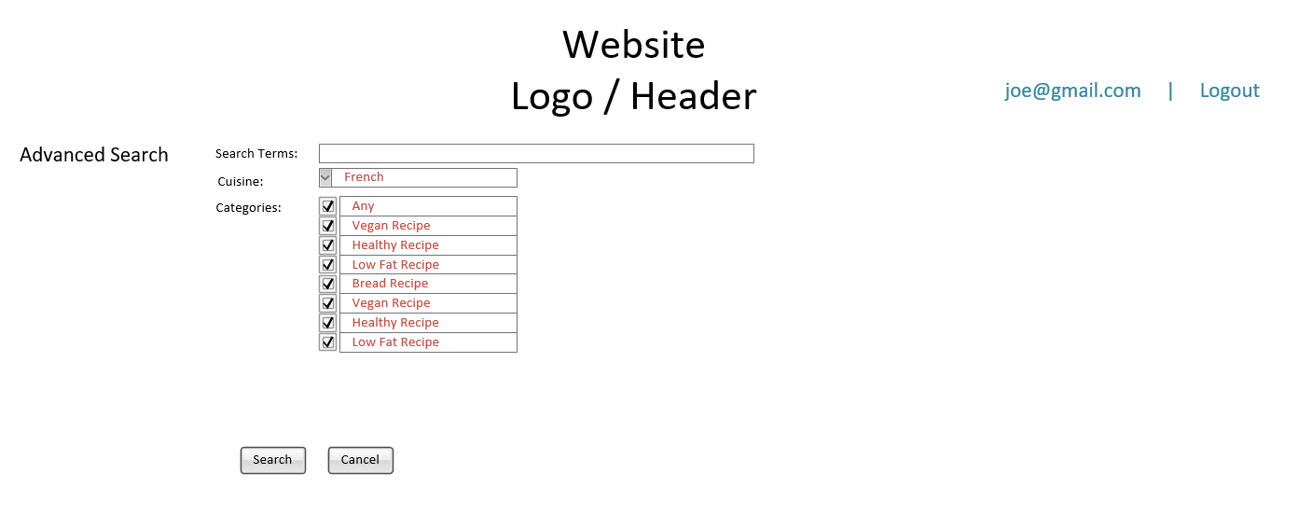

The Advanced Search Page must:

* Search terms are searched in all fields.
* Allow the user to search by a limited selection of cuisine type or categories
* Selecting ‘Any’ for a category should unselect all other values, ‘Any’ should be unchecked if the selection in the field is some of the available values.
* When the user selects a category mutually exclusive category (e.g. vegetarian, vegan and chicken etc) should be unselected.
* Searches executed from this page search ONLY the content types and fields selected by the user.
* Search results are displayed on the search results page as usual.
* No Search Term searched should return all items.

# Browse Page

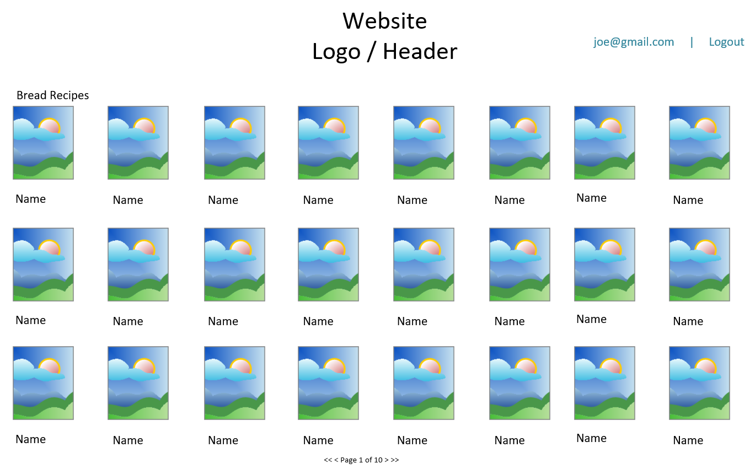

The Browse Page must:

* When the user selects “Bread Recipes”, “Chicken Recipes”, “Vegan Recipes” from the main page, they should land on the starting point of the browse page. This lists all of the categories under the content type.
* Choosing one of the categories takes you to a browse page and a breadcrumb is displayed in the top left to show the user what category they are browsing.
* All items matching the content type and category the user selected are then displayed.
* Clicking any item takes you to that item’s item detail page.